***SITE NETWORK!***

***[WORKER MANAGEMENT SYSTEM]***

***Empathise***

Here are 15 requirements for a comprehensive **Worker Management system**

1. **User Authentication and Access Control:**
   * The system should have robust user authentication mechanisms, including secure login methods such as email/password or multi-factor authentication.
   * It should allow for role-based access control to restrict access to sensitive information and features based on user roles and permissions.
   * The system should provide audit logs to track user activities and changes made to worker profiles or tasks.
2. **Worker Profile Management:**
   * The system should allow administrators to create and manage worker profiles, including basic information such as name, contact details, job title, and skills.
   * It should support the ability to assign specific roles or permissions to workers based on their job responsibilities and qualifications.
   * Workers should be able to update their own profiles, including uploading documents or certifications, and view their assigned tasks and schedules.
3. **Task Assignment and Management:**
   * The system should facilitate the assignment of tasks to workers, allowing administrators to create tasks, set priorities, deadlines, and allocate resources.
   * It should provide a centralized dashboard for administrators to track the status of tasks, monitor progress, and manage task assignments efficiently.
   * Workers should receive notifications and reminders about assigned tasks, including details such as task descriptions, deadlines, and any related documents or resources.
4. **Time and Attendance Tracking:**
   * The system should offer functionality for tracking worker attendance and work hours accurately, including clock-in/out features or timesheet submissions.
   * It should support different methods of time tracking, such as manual entry, biometric scans, or integration with time clock hardware.
   * Administrators should be able to generate reports on worker attendance, hours worked, overtime, and leave balances for payroll processing and compliance purposes.
5. **Payroll Management:**
   * The system should integrate with payroll processing tools or services to streamline the calculation and disbursement of worker salaries, wages, and benefits.
   * It should support the automation of payroll tasks, including tax deductions, overtime calculations, and deductions for benefits or leave.
   * Administrators should have access to detailed payroll reports and summaries, ensuring accuracy and compliance with labor regulations.
6. **Safety and Compliance Monitoring:**
   * The system should include features for tracking and managing worker safety training, certifications, and compliance with health and safety regulations.
   * It should provide alerts and notifications for expiring certifications or upcoming safety training requirements, ensuring that workers remain compliant.
   * Administrators should be able to generate reports on safety incidents, near misses, and corrective actions taken to mitigate risks and ensure a safe working environment.
7. **Secure Password policies**
   * It should require passwords to contain a combination of uppercase and lowercase letters, numbers, and special characters to enhance security.
   * The system should enforce strong password policies to ensure that user passwords meet minimum requirements for complexity, length, and uniqueness.
8. **Communication and Collaboration Tools:**
   * The system should include communication features such as messaging, chat, or discussion forums to facilitate collaboration and information sharing among workers and teams.
   * It should support file sharing, document collaboration, and project management functionalities to streamline communication and collaboration on tasks and projects.
   * Administrators should have the ability to broadcast announcements, updates, and important information to all workers or specific groups within the organization.
9. **Mobile Accessibility and Integration:**
   * The system should be accessible via mobile devices, allowing workers to access their profiles, tasks, schedules, and communication tools on-the-go.
   * It should support integration with other mobile applications or services commonly used by workers, such as calendar apps, messaging platforms, or GPS tracking tools.
   * Administrators should have the flexibility to manage worker profiles, tasks, and communication channels from both desktop and mobile interfaces seamlessly.
10. **Training and Development Opportunities:**
    * The system should provide access to training resources, courses, and educational materials to support the professional development and skills enhancement of workers.
    * It should track training completion and certification status for workers, helping administrators identify training needs and opportunities for skills development.
    * Administrators should be able to assign specific training modules or courses to individual workers or groups based on their job roles and performance goals.
11. **Data Security and Privacy:**
    * The system should adhere to industry best practices for data security and encryption to protect sensitive information such as worker profiles, payroll data, and communication records.
    * It should comply with data privacy regulations such as GDPR, HIPAA, or CCPA, ensuring that worker data is collected, stored, and processed in a secure and compliant manner.
    * Administrators should have access controls and data access permissions to manage access to sensitive information and prevent unauthorized access or data breaches.
12. **Scalability and Customization:**
    * The system should be scalable to accommodate the growth and changing needs of the organization, supporting an increasing number of workers, tasks, and projects over time.
    * It should offer customization options and flexibility to tailor workflows, forms, and interfaces to the specific requirements and processes of the organization.
    * Administrators should have the ability to configure settings, workflows, and integrations easily without requiring extensive technical expertise, enabling them to adapt the system to evolving business needs.
13. **Training and Support:**

* The system should provide comprehensive training materials, user guides, and support resources to help administrators learn how to use the system effectively and troubleshoot common issues.
* It should offer responsive customer support services, including online chat, email support, and phone assistance, to address any questions or concerns that administrators may have during system deployment and operation.

*Ideate:*

Here are some ideation on how to implement the features mentioned above in a **Worker Management System:**

1. **User Authentication and Access Control:**
   * Implement a secure login page with options for email/password login and multi-factor authentication.
   * Use role-based access control (RBAC) to define different user roles and permissions.
   * Log user activities and changes made to worker profiles or tasks for auditing purposes.
2. **Worker Profile Management:**
   * Create a user-friendly interface for administrators to add, edit, and view worker profiles.
   * Include fields for basic information, roles, and permissions, with options for uploading documents.
   * Allow workers to update their profiles and view their assigned tasks.
3. **Task Assignment and Management:**
   * Develop a dashboard for administrators to create, assign, and monitor tasks.
   * Include features for setting priorities, deadlines, and resource allocation.
   * Implement notifications for workers about assigned tasks and deadlines.
4. **Time and Attendance Tracking:**
   * Create a time tracking module for workers to log their hours.
   * Integrate with biometric scanners or time clock hardware.
   * Generate attendance reports for administrators.
5. **Payroll Management:**
   * Integrate with payroll processing tools for salary calculation and disbursement.
   * Automate tax deductions, overtime calculations, and benefit deductions.
   * Provide detailed payroll reports for administrators.
6. **Safety and Compliance Monitoring:**
   * Develop a module to track worker certifications and safety training.
   * Implement alerts for expiring certifications and safety training requirements.
   * Generate reports on safety incidents and corrective actions.
7. **Secure Password Policies:**
   * Enforce strong password policies with requirements for complexity and length.
   * Implement password encryption and salting techniques.
   * Provide options for password recovery and account lockout mechanisms.
8. **Communication and Collaboration Tools:**
   * Include messaging, chat, and discussion forums for collaboration.
   * Support file sharing and document collaboration.
   * Enable administrators to broadcast announcements and updates.
9. **Mobile Accessibility and Integration:**
   * Develop a mobile app for workers to access profiles, tasks, and communication tools.
   * Integrate with calendar apps, messaging platforms, and GPS tracking tools.
   * Ensure seamless access and management from both desktop and mobile interfaces.
10. **Training and Development Opportunities:**
    * Provide access to training resources and courses within the system.
    * Track training completion and certification status.
    * Allow administrators to assign training modules based on roles and performance goals.
11. **Data Security and Privacy:**
    * Adhere to industry best practices for data security and encryption.
    * Comply with data privacy regulations and implement access controls.
    * Provide comprehensive training and support for administrators on data security measures.
12. **Scalability and Customization:**
    * Design the system to be scalable to accommodate growth.
    * Offer customization options for workflows and interfaces.
    * Provide configuration settings for administrators to adapt the system to their needs.
13. **Training and Support:**
    * Develop comprehensive training materials and user guides.
    * Offer responsive customer support services for assistance.
    * Provide ongoing updates and improvements based on user feedback.

*Define*

The worker management system provides administrators with comprehensive tools for managing worker profiles, tasks, time and attendance, payroll, safety, and compliance, ensuring efficient workforce management while maintaining regulatory compliance and safety standards.

Key Features:

1. **User Authentication and Access Control:**
   * Secure login methods and role-based access control to manage user access and permissions, with audit logs for activity tracking.
2. **Worker Profile Management:**
   * Administrators can create and manage worker profiles, assign roles, and allow workers to update their own information and view tasks.
3. **Task Assignment and Management:**
   * Administrators can create tasks, set priorities and deadlines, and allocate resources, with a centralized dashboard for tracking and notifications for workers.
4. **Time and Attendance Tracking:**
   * Functionality for accurately tracking worker attendance and hours worked, supporting various time tracking methods and generating attendance reports.
5. **Payroll Management:**

Integration with payroll processing tools for salary calculation and automation of payroll tasks, providing administrators with access to detailed payroll reports.

1. **Safety and Compliance Monitoring:**
   * Features for tracking worker safety training, certifications, and compliance, with alerts for expiring certifications and generation of safety incident reports.

*OBE or PBL Chart*

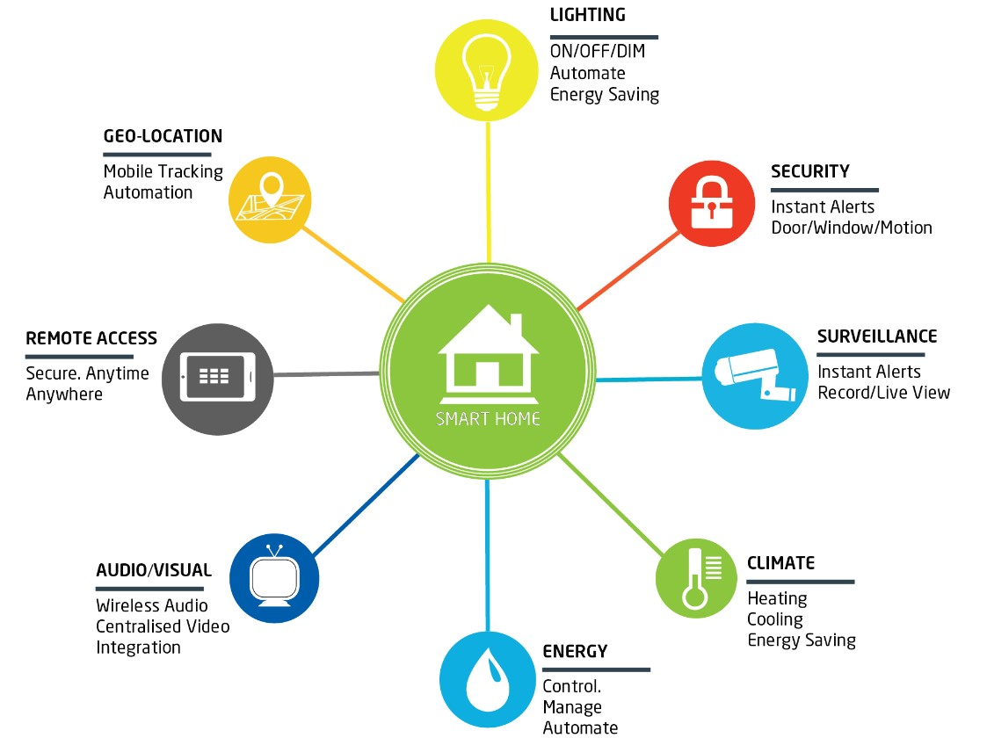

*Testing(Test Cases)*

Here’s a test case for each of the requirements mentioned above in the Empathise section:

1. **User Authentication and Access Control:**
   * Secure login methods such as email/password or multi-factor authentication.
   * Role-based access control to manage user permissions.
   * Audit logs to track user activities.
2. **Worker Profile Management:**
   * Creation and management of worker profiles with basic information and skills.
   * Assignment of roles and permissions to workers.
   * Self-service capabilities for workers to update their profiles.
3. **Task Assignment and Management:**
   * Creation, assignment, and monitoring of tasks by administrators.
   * Centralized dashboard for tracking task status and progress.
   * Notifications and reminders for workers about assigned tasks.
4. **Time and Attendance Tracking:**
   * Tracking of worker attendance and work hours.
   * Support for various time tracking methods.
   * Generation of attendance reports for administrators.
5. **Payroll Management:**
   * Integration with payroll processing tools for salary calculation and disbursement.
   * Automation of payroll tasks including tax deductions and benefits calculations.
   * Access to detailed payroll reports for administrators.
6. **Safety and Compliance Monitoring:**
   * Tracking and management of worker safety training and certifications.
   * Alerts for expiring certifications and safety training requirements.
   * Generation of safety incident reports.